Rec 4 Part 2

1. 1st strategy

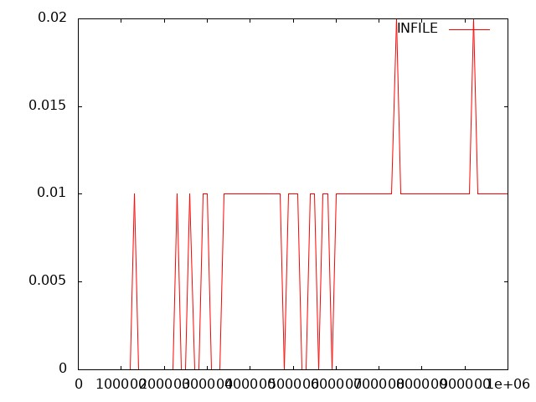

In this strategy I changed the value of datatype so when it did it is resizing 4 times da->capacity which means when increase in size the time is decreasing. When compared to times 2. Because it is allocating 4 time of the memory which is more than what actually is needed but here the disadvantage is wastage of memory.

if (da->size == da->capacity) {

_dynarray_resize (da, 4 * da->capacity);

1. 2nd strategy

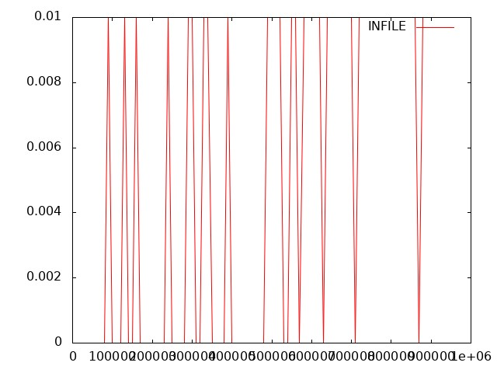

In second strategy this same and here the size is increased to 8 times so we can see the time is decreased in graph so from above to strategies it states that when the size is increased to allocate memory even in advance is helping to reduce time but the located memory if its not useful then there is a disadvantage of memory loss.

if (da->size == da->capacity) {

_dynarray_resize (da, 8 * da->capacity);

1. 3rd strategy

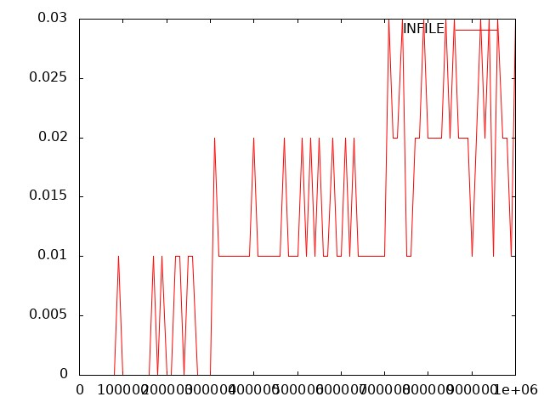  
  
Here we can see that the time is increased when compare to other to strategies this is because in here I changed the condition by mention if the da->size is >= 75 % then resize the da->capacity. So, for sure the time will be increased

//if (da->size >= (3.0/4.0*(da->capacity))) {

//_dynarray_resize (da, 2 * da->capacity);}